
Flat wire Coil Receiving - SRS

Document Change History
Version | Author | Updated on | Reviewer | Reviewed on | Description
1.0 | Jaspreet | [dd-mm | [Name] | [dd-mmm-yy] | [max 10 words]

Contact | Details

Table of Content
Flat wire Coil Receiving - SRS 0
Document Change History 1
1. Feature Description 3
1.1.1. UI Changes 3

  - Feature Description
[Guideline: This section provides the details for the user interfaces for the described feature. This section will have the screenshots of designs, interaction details, validations on the UI, etc.]

Coil Receiving

When a Rod received, it is received as bundle from vendor on coil receiving system.
In case of non EDI received: We will enter diameter, net and gross weight of the received material.
In case of EDI : We will measure the gross weight(scale weight). Compare it with EDI weight
Enter only purchase order no instead of parameters. Parameters are pulled from PO.
Validations:
We will archive R series in coils table and Start with R00001.
If scale weight is not in tolerance with vendor gross weight.
If this validations fail then rod should be put in suspended state.
Note: We will have Rodno , gauge, alloy, temper, weight, not available – Width
We need to confirm traceability to come up form the vendor. Only weight validations will happened.
Rod chemistries are required without which the rod will be suspended.

    - UI Changes
Receive Coil with EDI
In Coil receiving > Scanned PackageID:

Once user inserts the package ID and clicks on Proceed:

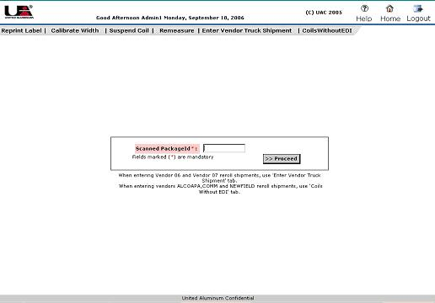
Below screen will open:
In case of Coil:
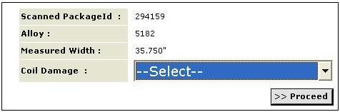
Updated in case of Rod:
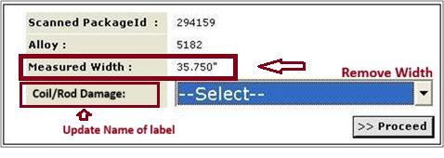

5.3.2 Coil/Rod Number Generation Logic for Rod
Rod no will be generated using format R12345ABC, it will start from R00001 will go till R99999 and no nos will be left based on lot no every received Rod will have its Rod no incremented by 1.

5.3.3 Logic to Enter rows in Master_coils table
Same logic will apply as current system.

5.3.4 Coil Suspension Logic
All rules will apply except
Rule 5. If EDI width is not equal to PO width i.e.

5.3.5 Logic to enter row in Coils table: To be discussed, Gauge will be updated in Gauge, Width will be blank, Surface Finish will be blank, Inventory type to be discussed. Coil ID and Coil OD will be blank
5.3.7 Logic to Move the chemistries from EDI to the permanent chemistry’s tables
Same logic will apply as current system.

5.3.8 Multiple PackageId handling
Same logic will apply as current system.

5.3.9 Create Entry in Lots
Same logic will apply as current system.
Neef to archeive data for R
Lot no generation logic needs to be updated

5.3.10 Condition Code Logic
Same logic will apply as current system.

5.3.11 Updating the Vendor_product_test_info table
Same logic will apply as current system.

5.3.13 Print labels

Need to discuss

5.3.14 Suspend Coil
Same logic will apply as current system.

Coil Receiving without EDI

All fields will be same as in current system and logic will work in same way

